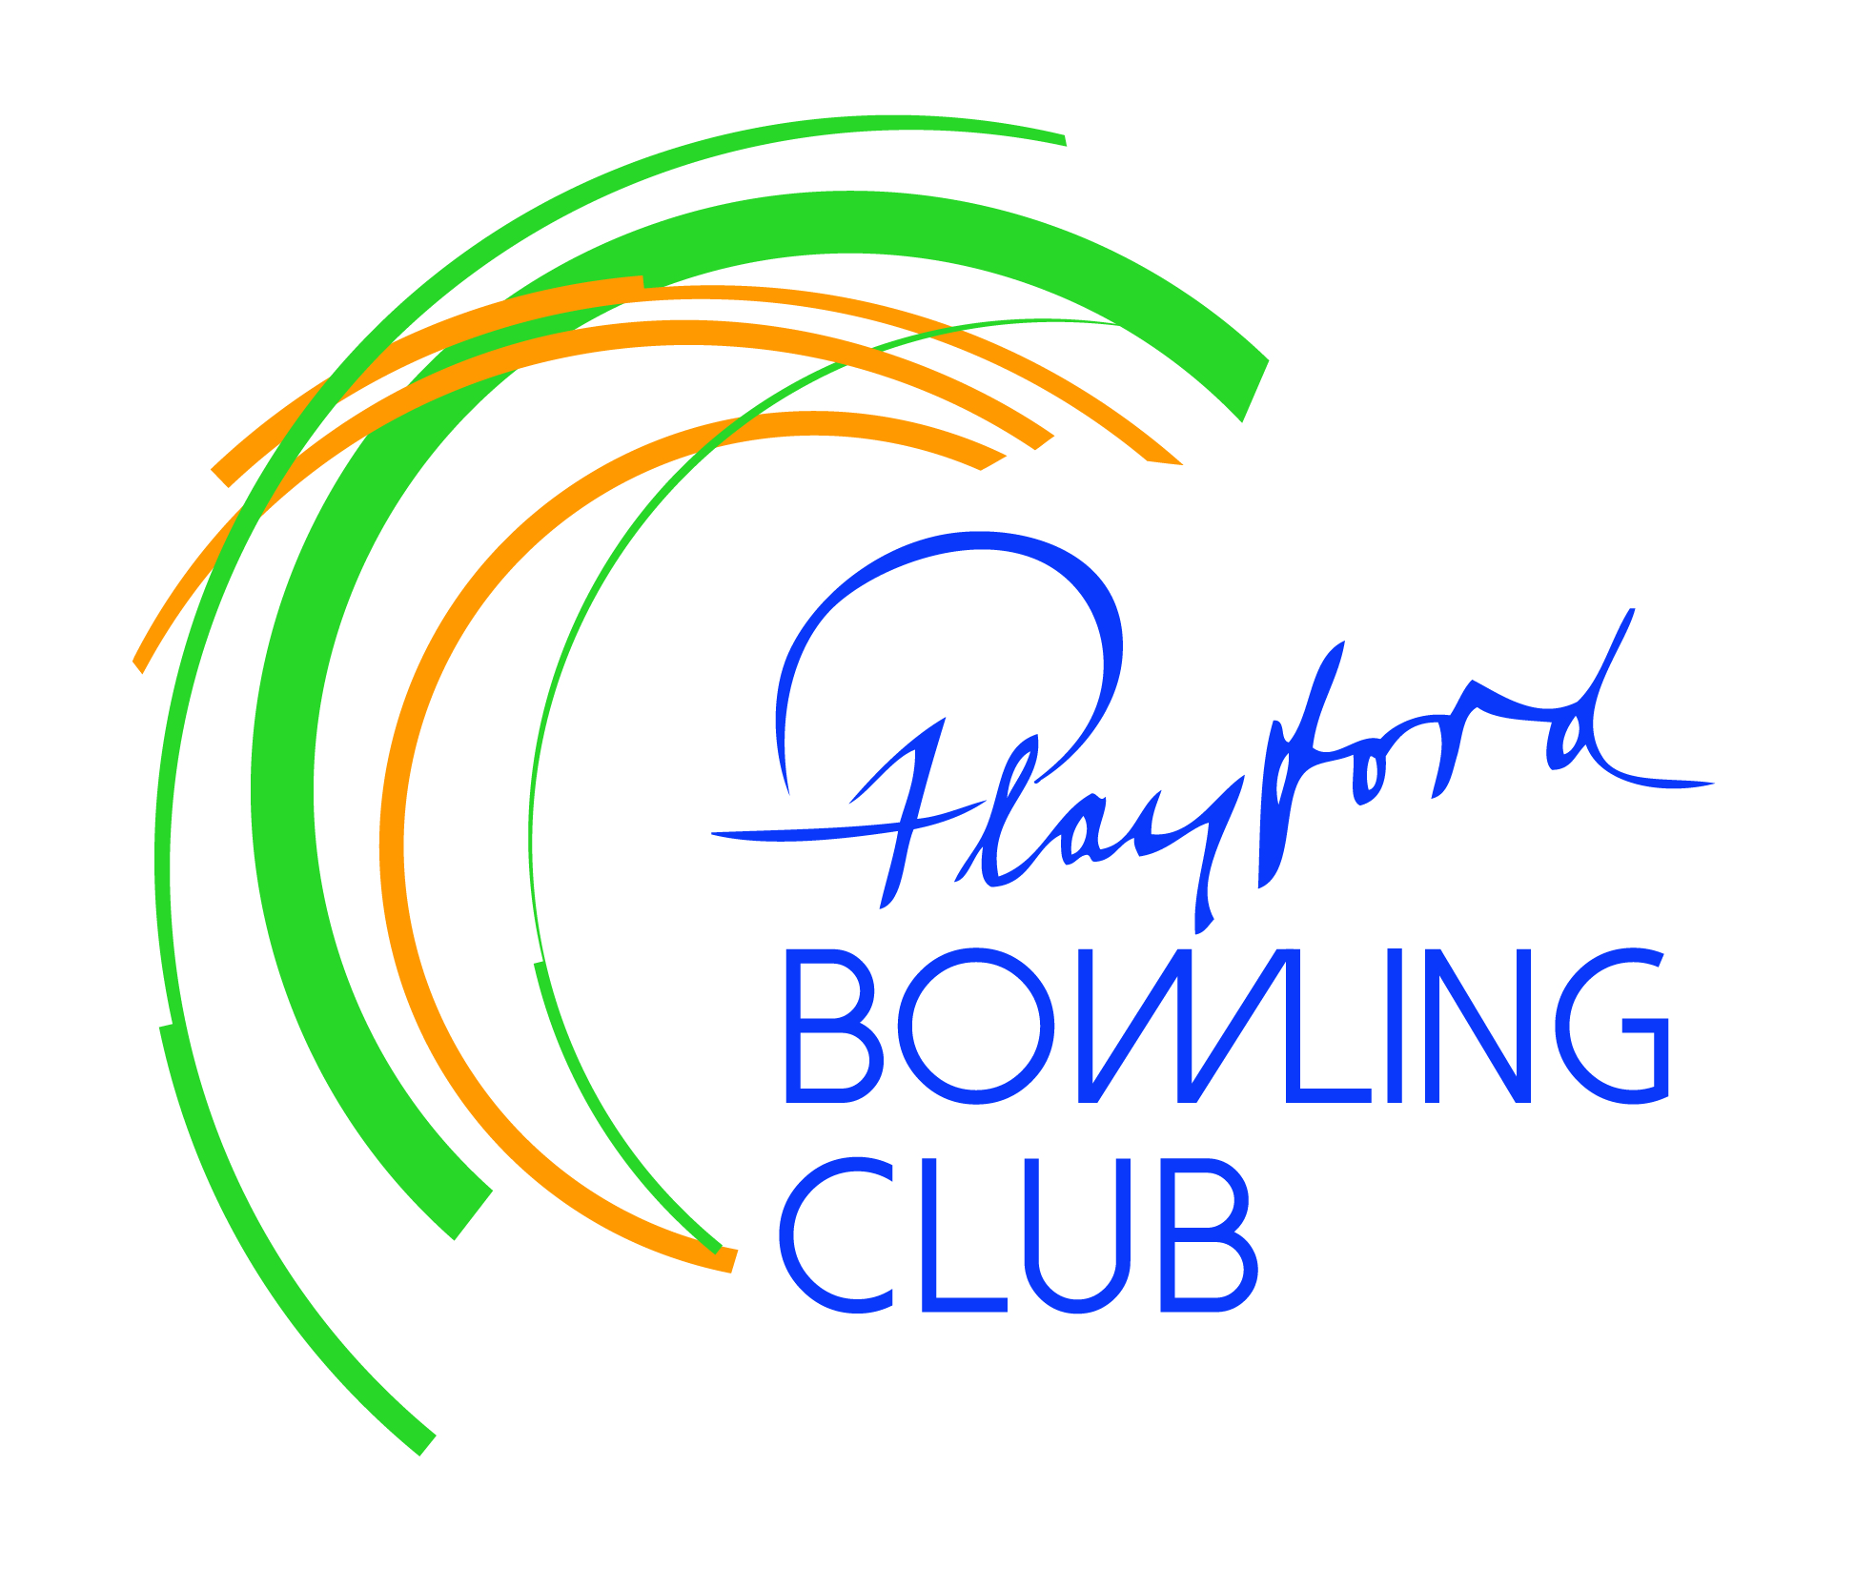
Playford Bowling Club Inc.
PO Box 34 Elizabeth SA 5112

June Newsletter

President’s Report

Thanks to all those members who attended the AGM and especially those who stood for various board or Chairperson of Selectors (CoS) positions. Whether successful or not, you showed a willingness to take on extra responsibilities to help the club move forward.
The board for the 2026/27 season is:

President: Steve Attridge (1 year remaining in current term)
Vice-President (Men): Ron Slager (2 years)
Vice-President (Ladies): Chris Butler (2 years)
Treasurer: Craig Eckert (1 year)
Secretary: Erilyn Dutton (2 years)
Board members: T Johnston (1 year), A Thompson (1 year) D Glover (2 years), T Bettens (2 years)

Chair of Selectors: M Keenan (Open), P Hutchinson (Mens), L Ruddock (Ladies) – all 1 year terms.

Many congratulations to Brian Glover and Ron Slager, each of whom was awarded Life Membership of our club in recognition of outstanding service over many years.

Club championship finalists and Thursday night Triples Champions were presented with trophies.
Craig Eckert was awarded Playford’s Volunteer of the Year for 2026, joining an illustrious group to have received the club’s most prestigious annual trophy.

During the meeting the board’s recommended membership fee structure was endorsed by the general membership, as was the scale of honoraria for our various managerial positions.
Following on from discussion at the 2025 AGM Craig Eckert presented three options for our club shirt. The resulting vote was in favour of retaining our current strip. Given the number of shirts we give out to new members, and the need for others to replace existing shirts, the board decided that this issue would not be canvassed again for at least the next couple of years.

At the first meeting of the new board, the following applicants were appointed:

Bar Manager: Andy Crawford
Kitchen managers: Sherryll Kendall and Mardi Johnston
Greenkeepers: Ron Slager and Terry Bettens
Cleaners: Erilyn Dutton and Sam Goodwin
Tournament directors: Tony Johnston (external) and Terry Bettens (internal)
Facility managers: Andy Crawford and Terry Bettens

Lyn Ruddock, Sherryll Kendall, Mardi Johnston, Marion Crawford and Di Gibbard volunteered to form a committee to organise the club’s social events, with Lyn Ruddock acting as convenor.

Steve Attridge

PBC Runner-up in Bowls SA “Large Club of the Year”

After making the list of finalists for the 2023 “Large Club of the Year”, this year we finished as runners-up. Third time lucky?? We were also a finalist in the Bowls SA 2026 Community Spirit category. We aim to be valued members of the state bowling community and of the wider Playford community and these nominations are a tremendous endorsement of our young club.

Facility upgrades

The canopy above B green will be cleaned mid-June, after which this green will be scarified. C green will receive similar attention in July.
The board is aware that in warm weather it gets hot beneath the polycarbonate sheeting on the covered walkway at the northern end of C green. Tel Bettens now has board approval to purchase and install metal Stratco sheets to alleviate this problem.
When both of these projects are complete it will bring to $38000 the amount spent on capital improvements in the past 18 months.

Upcoming Events

June 21st - Big Morning Tea – fundraiser for Anti-Cancer.

July 3rd - Schitty Night – payments to Sherryll or Mardi please

August 9th - Past Players’ Memorial Tournament
Once again generously sponsored by Smithfield & Elizabeth Funeral Directors.
Limited spots remain if you’d like to enter – see Tony Johnston

August 28th - Trivia Night – see flyer on noticeboard

Miscellaneous

Anyone wishing to serve as a selector for next season’s Wednesday or Saturday pennant competitions should add apply via the sheets on the noticeboard. Candidates should be familiar with – and willing to abide by - the club’s selection guidelines. Interviews will be arranged in due course.

Membership fees for season 2026/27 can be paid at any time – please see our new secretary Erilyn Dutton to complete your renewal form. A reminder that anyone who wishes to have access to the greens – for social bowls or practice – must be an Associate or Full member.

A new bingo roster will be available soon. Please check the dates and swap shifts with someone if necessary, then let Steve or Andy know. Thanks to all those who volunteer for this task.

There is a suggestion box on the small table on the right as you enter the club. Constructive suggestions are welcome provided they are signed.

Erilyn Dutton will be taking over responsibility for the club’s newsletters. Please see her to publicise any upcoming events or to advise of significant personal milestones or achievements.

